Yönetim Kurulu Başkanı Halil Baştürkmen video Konferans aracılığıyla Ar_Ge ve İnovasyon Kurulu toplantısında sektörün sorunları ile ilgili görüşlerini belirti.

[[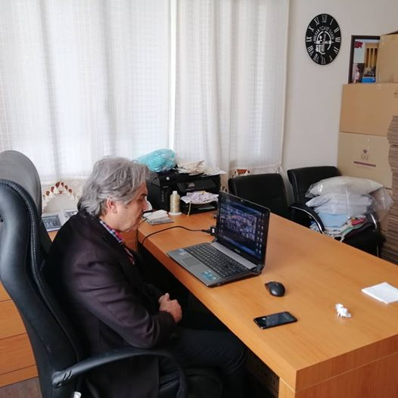](https://www.facebook.com/buldanticaretodasi/photos/a.374115932770523/1477287075786731/?type=3&eid=ARCvFzPoypjQgIi1_eto_i-D0GKmYk0xy-WzE3Ofcj9aQyPcqcpsstuAe8nvUt0fxjiJrBqt1X-uOIJf&__xts__%5B0%5D=68.ARCgogHUO8ar7cUQQ86AkyP8hKnkOBKg9GjviXdumvJyeg4Ca4AYsdFV4HcpWwJYbQ5d-_yEY-YtkLmm8ci3czaNtn4fbIEmoaQsJP43LiCY0cnkTO35GGlETmbdALkkDBf8_We4AXNqf6oLpblS7c7bEWuNtz9BFbP26uZeSWnSl9ipE2tkvtOc1nTxCPEsrlro4HwhTLMVI6gYI1LPLnMpF8oG655M2jOqEiNuvqUC36qvCFOTOkug980z-odWSRvTjPXZ-6rqKn2flGzagMewcG3igU6zTYpvNwR6mqtn0w9mgY-eTcQ5phbqI8BuC001QrSeEtZ58KmswYigIFpO0w&__tn__=EEHH-R)](https://www.facebook.com/buldanticaretodasi/photos/a.374115932770523/1477287075786731/?type=3&eid=ARCvFzPoypjQgIi1_eto_i-D0GKmYk0xy-WzE3Ofcj9aQyPcqcpsstuAe8nvUt0fxjiJrBqt1X-uOIJf&__xts__%5B0%5D=68.ARCgogHUO8ar7cUQQ86AkyP8hKnkOBKg9GjviXdumvJyeg4Ca4AYsdFV4HcpWwJYbQ5d-_yEY-YtkLmm8ci3czaNtn4fbIEmoaQsJP43LiCY0cnkTO35GGlETmbdALkkDBf8_We4AXNqf6oLpblS7c7bEWuNtz9BFbP26uZeSWnSl9ipE2tkvtOc1nTxCPEsrlro4HwhTLMVI6gYI1LPLnMpF8oG655M2jOqEiNuvqUC36qvCFOTOkug980z-odWSRvTjPXZ-6rqKn2flGzagMewcG3igU6zTYpvNwR6mqtn0w9mgY-eTcQ5phbqI8BuC001QrSeEtZ58KmswYigIFpO0w&__tn__=EEHH-R)

Taleplerimiz doğrultusunda Halk Bankası Cansuyu paketinden oda üyelerimizinde faydalanması için yapmış olduğumuz çalışmalar meyvesini verdi bu konuda herzaman yanımızda olan Birlik Başkanımız Rıfat Hisarcıklıoğlu na teşekkür ederim. Üyelerimize hayırlı olsun Buldan Ticaret odası Yönetim Kurulu Başkanı Halil Baştürkmen...

[[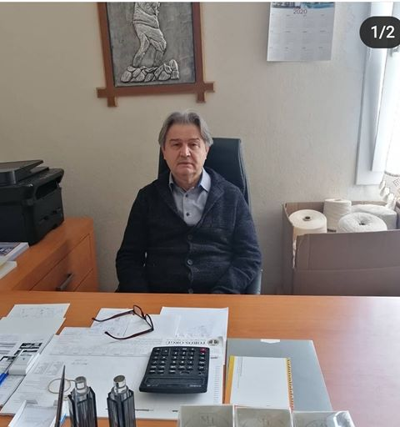](https://www.facebook.com/buldanticaretodasi/photos/pcb.1490431014472337/1490430921139013/?type=3&__tn__=HH-R&eid=ARCVW0goK_6PqytCXLnGcP46XVqETTZ8BCR0F-xV8Fy-r3sWo1mDuAeQoiviAm9SFnUKiQcvTtie41Aa&__xts__%5B0%5D=68.ARByFbdX1JCY4_WOyf0UoBvOcQlOiPoYJq2JmVGwszGwtQJCB3rYwAzXb6_9vo_VyoOlArs_Eu0PRY8uNWTt8CQKqS7BTJjgOiq7kfEbL3W5twc9PjOxhEML24jZ_e4Z2cAgjg8ilCPISEfrnytm7IyDv7GuXkorqmVNyqv5fKzH-ezTaITLK8GM3-31Y_lT6YEIdnlwoxQb91YZtJDbqbpTlu3FDwdzdrLVVqmLHbQ8h4gWM2gBTH4d3rjiZaMg2Je2T9LIkDr1cjgMMs2K7LVN9FF1fTTZk2TTR3nAdh4XA-jI6ICFEuf5A6B2mTjkJ3TA2RUW98z_bde4pDqLjJZP_w)](https://www.facebook.com/buldanticaretodasi/photos/pcb.1490431014472337/1490430921139013/?type=3&__tn__=HH-R&eid=ARCVW0goK_6PqytCXLnGcP46XVqETTZ8BCR0F-xV8Fy-r3sWo1mDuAeQoiviAm9SFnUKiQcvTtie41Aa&__xts__%5B0%5D=68.ARByFbdX1JCY4_WOyf0UoBvOcQlOiPoYJq2JmVGwszGwtQJCB3rYwAzXb6_9vo_VyoOlArs_Eu0PRY8uNWTt8CQKqS7BTJjgOiq7kfEbL3W5twc9PjOxhEML24jZ_e4Z2cAgjg8ilCPISEfrnytm7IyDv7GuXkorqmVNyqv5fKzH-ezTaITLK8GM3-31Y_lT6YEIdnlwoxQb91YZtJDbqbpTlu3FDwdzdrLVVqmLHbQ8h4gWM2gBTH4d3rjiZaMg2Je2T9LIkDr1cjgMMs2K7LVN9FF1fTTZk2TTR3nAdh4XA-jI6ICFEuf5A6B2mTjkJ3TA2RUW98z_bde4pDqLjJZP_w)

Buldan Ticaret Odası Meclis Başkanı İbrahim Acıkara ve Genel Sekreter Ayhan Emirdağ, Denizli Ticaret Odasında düzenlenen Denizbank ile yapılan nefes kredisi protokolü imza törenine katıldılar. Odamız üyelerine hayırlı olmasını temenni ediyoruz.

[[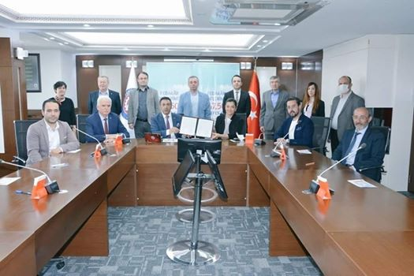](https://www.facebook.com/buldanticaretodasi/photos/pcb.1490601461121959/1490600894455349/?type=3&__tn__=HH-R&eid=ARA1m1i2fu41FYZ2YVEoKj5THmqhrvDyDBgiX8hfoGMdgeoFgYl8Kbtt_-Pn1HssLH4yWu-G-Bel7qIM&__xts__%5B0%5D=68.ARCX6dDSkCmIxl0QnOQmLVrKx69gSMQtTeKAyiFiCu_1qnVTRuFs2BGuGq7nx-RF5M68tq_CIGQwkxXaCjfJqkMtqzFmUtULlZUVNM_3BZejXepNMdQn138xQgIQkMap_3AIw7jldMyc_OuCrWx9E9PLRq6Bg7O15kbA4dMZm7IEzobEdkM-BdlGFjCFfDlOcpIaRd17lOgWCJRdDXPavgDGfRi7_ek6BQPXAWjg-zraRSLfEAA4E9OhB-Mh85sAh1hOI9sE5k8uhii1cZwF8XXVlsy-21QaislkNkonvhGNCvigBzQtjvUEWM0y6Obl7AaaEn9nhviVKp-CDkmGDOp9Cg)](https://www.facebook.com/buldanticaretodasi/photos/pcb.1490601461121959/1490600894455349/?type=3&__tn__=HH-R&eid=ARA1m1i2fu41FYZ2YVEoKj5THmqhrvDyDBgiX8hfoGMdgeoFgYl8Kbtt_-Pn1HssLH4yWu-G-Bel7qIM&__xts__%5B0%5D=68.ARCX6dDSkCmIxl0QnOQmLVrKx69gSMQtTeKAyiFiCu_1qnVTRuFs2BGuGq7nx-RF5M68tq_CIGQwkxXaCjfJqkMtqzFmUtULlZUVNM_3BZejXepNMdQn138xQgIQkMap_3AIw7jldMyc_OuCrWx9E9PLRq6Bg7O15kbA4dMZm7IEzobEdkM-BdlGFjCFfDlOcpIaRd17lOgWCJRdDXPavgDGfRi7_ek6BQPXAWjg-zraRSLfEAA4E9OhB-Mh85sAh1hOI9sE5k8uhii1cZwF8XXVlsy-21QaislkNkonvhGNCvigBzQtjvUEWM0y6Obl7AaaEn9nhviVKp-CDkmGDOp9Cg)

Hazine ve Maliye Bakanımız Sn. Dr. Berat ALBAYRAK'ın ve Birlik Başkanımız Sn. M.Rifat HİSARCIKLIOĞLU'nun katılımları ile gerçekleşen toplantıya Odamız Yönetim Kurulu Başkanı Halil BAŞTÜRKMEN katılmıştır.

[[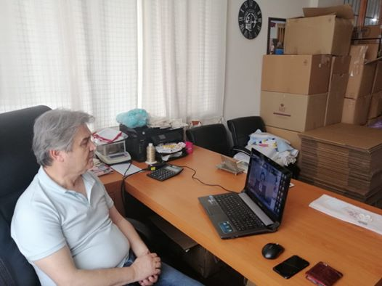](https://www.facebook.com/buldanticaretodasi/photos/a.236108109904640/1508868185961953/?type=3&eid=ARB7jRCQFMMlhrr2UI10-b7W2lLr8o5Oymc612fZIeKIN632DQ1E-7fRUWQE33ceKSQRnfA0adVosZ_8&__xts__%5B0%5D=68.ARDOXuD8e95SoHuquYHCJ7whYz2yqWFCDLvYRQajSKyfFfc9MYm5OUBZVSfljijg8s50XZHYwALmxeC8Ulq5uejWS0Srx8QQ1q7yUU24fjEIBA_MrhPIGRcGCsXdwaaP2abDgelwthqEmr9e5GvoUFv5C-YpUNDGU-BQanWYn30oSKPDOkyhKiwqQL4OS-a_vla5aYQVgcs1TOWylqx8vrT4mExLkKs_5MwbpFkZM_0O2nOsWU9aeUpWcazUieg-QI2NKmaTGBkhCsND6El8jPj89sRrJNC3SUplZNeDZEhNNKvejS1aPEO7Cv7Qg0hsFE6WwP_lQkOGbhwuAfSQGA4F-w&__tn__=EHH-R)](https://www.facebook.com/buldanticaretodasi/photos/a.236108109904640/1508868185961953/?type=3&eid=ARB7jRCQFMMlhrr2UI10-b7W2lLr8o5Oymc612fZIeKIN632DQ1E-7fRUWQE33ceKSQRnfA0adVosZ_8&__xts__%5B0%5D=68.ARDOXuD8e95SoHuquYHCJ7whYz2yqWFCDLvYRQajSKyfFfc9MYm5OUBZVSfljijg8s50XZHYwALmxeC8Ulq5uejWS0Srx8QQ1q7yUU24fjEIBA_MrhPIGRcGCsXdwaaP2abDgelwthqEmr9e5GvoUFv5C-YpUNDGU-BQanWYn30oSKPDOkyhKiwqQL4OS-a_vla5aYQVgcs1TOWylqx8vrT4mExLkKs_5MwbpFkZM_0O2nOsWU9aeUpWcazUieg-QI2NKmaTGBkhCsND6El8jPj89sRrJNC3SUplZNeDZEhNNKvejS1aPEO7Cv7Qg0hsFE6WwP_lQkOGbhwuAfSQGA4F-w&__tn__=EHH-R)

Tarım ve Orman Bakanımız Sayın Bekir Pakdemirlinin katıldığı programa Yönetim Kurulu Başkanı Halil Baştürkmen katıldı..

[[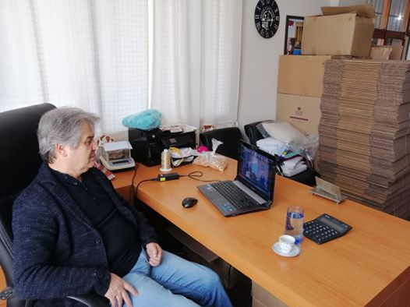](https://www.facebook.com/buldanticaretodasi/photos/pcb.1520766161438822/1520766038105501/?type=3&__tn__=HH-R&eid=ARAOAryorhaao1esE_rxR2AS_WSWYIEAnk9BdzJgV1_ljvPTpqO_FzrGbmWtEhn-GoIN-WJmQ7_fz4jv&__xts__%5B0%5D=68.ARBAWKLLORYvOnDVfqkAFSi_njAj4ac-65CuLe1eJWgr2X2buPvAopykw3091_qXPxq5iuOjlwVUNPKhuaa7zg3nJ_i_OkZDpKsA9ltUrkkPbQqWj22Vi0BOhIk2tvK98vXFVEbQZW43rezoY35c19hNGnsLhbqPxi_uNKugEfWjVP0XhT6GIpeGtyouP5Hresr5O-0FytySQUIq1oDYmYve4ehpf-nenqjYvD80aXWIo9GotO3IhyFev0OjT4e5RVFPvlPVPKLk3pt-G_JDJB15wW2CTur4VgH_6i7zzGlu7Yvm1fV928PePUNoXcmg6Fknq_Lm0xwJCMqZZxqhMXwG4A)](https://www.facebook.com/buldanticaretodasi/photos/pcb.1520766161438822/1520766038105501/?type=3&__tn__=HH-R&eid=ARAOAryorhaao1esE_rxR2AS_WSWYIEAnk9BdzJgV1_ljvPTpqO_FzrGbmWtEhn-GoIN-WJmQ7_fz4jv&__xts__%5B0%5D=68.ARBAWKLLORYvOnDVfqkAFSi_njAj4ac-65CuLe1eJWgr2X2buPvAopykw3091_qXPxq5iuOjlwVUNPKhuaa7zg3nJ_i_OkZDpKsA9ltUrkkPbQqWj22Vi0BOhIk2tvK98vXFVEbQZW43rezoY35c19hNGnsLhbqPxi_uNKugEfWjVP0XhT6GIpeGtyouP5Hresr5O-0FytySQUIq1oDYmYve4ehpf-nenqjYvD80aXWIo9GotO3IhyFev0OjT4e5RVFPvlPVPKLk3pt-G_JDJB15wW2CTur4VgH_6i7zzGlu7Yvm1fV928PePUNoXcmg6Fknq_Lm0xwJCMqZZxqhMXwG4A)

TOBB un 11.dönemler için düzenlediği Stratejik Planlama egitimine odamız olarak katıldık.

[[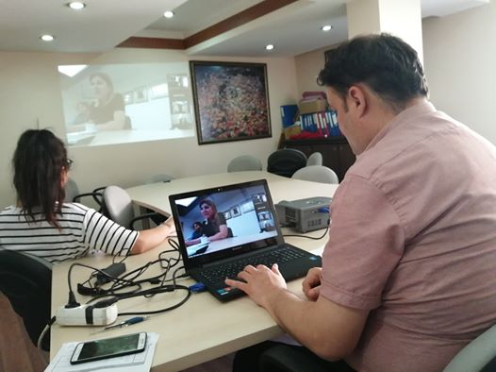](https://www.facebook.com/buldanticaretodasi/photos/a.374115932770523/1525187957663309/?type=3&eid=ARD71qvhLSex_AvYOMccyNfbsjl4CNpIF81B17o2zYbUmzbquOiU9GEI2ntYqhpBv6k3fztM-08aGiKr&__xts__%5B0%5D=68.ARCy8hXs18VIalMC-VHZiFAAPv73RRzbgisBKKWF4ABYXPCwps62xUB2vzn4HWq3xMM6ufpj3OlmUCpwunm3hTXekssDOySaxoEqhF5RHiggh95I5QniTPubxfH6h3xERZ3O1Q6aiDlu1Wjpu0jlUXRaxV7mrm-NVdF8gvyNDi5Y64Yze_f4YoDidPAr-e3fK6HgRoEKoIgG3_4NWw7blBO4iCCf5j8hhOWF5zLLDjRHQbcZOnAoZUHJS1N62uxrFYvg_aeAT0VG7j_uYrwxOlNnx50_d_FjiwPmGAFEc-uiJq18_fznU4wMD6saZ-4llcLqWsNEIFuGcY9z9t_CERPW1w&__tn__=EHH-R)](https://www.facebook.com/buldanticaretodasi/photos/a.374115932770523/1525187957663309/?type=3&eid=ARD71qvhLSex_AvYOMccyNfbsjl4CNpIF81B17o2zYbUmzbquOiU9GEI2ntYqhpBv6k3fztM-08aGiKr&__xts__%5B0%5D=68.ARCy8hXs18VIalMC-VHZiFAAPv73RRzbgisBKKWF4ABYXPCwps62xUB2vzn4HWq3xMM6ufpj3OlmUCpwunm3hTXekssDOySaxoEqhF5RHiggh95I5QniTPubxfH6h3xERZ3O1Q6aiDlu1Wjpu0jlUXRaxV7mrm-NVdF8gvyNDi5Y64Yze_f4YoDidPAr-e3fK6HgRoEKoIgG3_4NWw7blBO4iCCf5j8hhOWF5zLLDjRHQbcZOnAoZUHJS1N62uxrFYvg_aeAT0VG7j_uYrwxOlNnx50_d_FjiwPmGAFEc-uiJq18_fznU4wMD6saZ-4llcLqWsNEIFuGcY9z9t_CERPW1w&__tn__=EHH-R)

Ticaret Sicil E_belge sistemi eğitimine odamız Genel Sekreteri Ayhan Emirdağ katıldı.

[[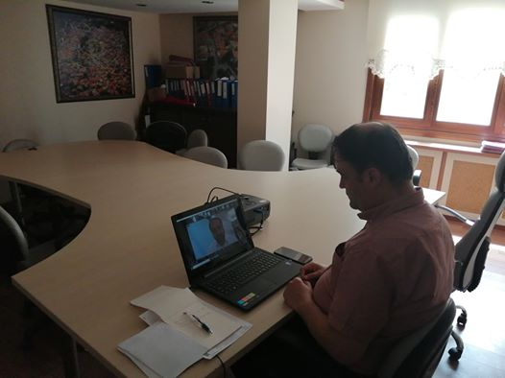](https://www.facebook.com/buldanticaretodasi/photos/a.374115932770523/1526149597567145/?type=3&eid=ARCJo7UKMGSAX2YCPx_SQmYODecHInIf4HPqKSe43OAbg7avkFUNBtZp44eoul78bk1Fosr4mlaCFdRY&__xts__%5B0%5D=68.ARBa4WDOdYrl9FiX9A7WKg0AIUv4uNUT4BO-21mo8buHNLxcWJ5XEW5ceFG7Px5PHfy860miS1njHwaJjbMtz52KjCez9RBhwldaz4zjN6UA_jb7NB5eJ_WF6uWrc5C6gXVLyqMsCCwVNzaof6p0B4J9IRqzF9XmkcZHPxuvpgfCpn976JpkVyNBd01Ty8lz5pgwd7uvxT8l_S0Qk9zgduSn4fPEKCTj7yVZURw2cNd2ARZFB_u09YWaF7qcbbUn7HUMokl9jy4NRDVDyngDIhW1mbc99djEl_l-ldzuTVQH_F2HNIsBztgPtJ0c0qzN4c9WlBEh6Kv7H5DGY6pLsVBGdw&__tn__=EHH-R)](https://www.facebook.com/buldanticaretodasi/photos/a.374115932770523/1526149597567145/?type=3&eid=ARCJo7UKMGSAX2YCPx_SQmYODecHInIf4HPqKSe43OAbg7avkFUNBtZp44eoul78bk1Fosr4mlaCFdRY&__xts__%5B0%5D=68.ARBa4WDOdYrl9FiX9A7WKg0AIUv4uNUT4BO-21mo8buHNLxcWJ5XEW5ceFG7Px5PHfy860miS1njHwaJjbMtz52KjCez9RBhwldaz4zjN6UA_jb7NB5eJ_WF6uWrc5C6gXVLyqMsCCwVNzaof6p0B4J9IRqzF9XmkcZHPxuvpgfCpn976JpkVyNBd01Ty8lz5pgwd7uvxT8l_S0Qk9zgduSn4fPEKCTj7yVZURw2cNd2ARZFB_u09YWaF7qcbbUn7HUMokl9jy4NRDVDyngDIhW1mbc99djEl_l-ldzuTVQH_F2HNIsBztgPtJ0c0qzN4c9WlBEh6Kv7H5DGY6pLsVBGdw&__tn__=EHH-R)

Evlatlarına dürüst, onurlu ve adil olmaları için yaşamları boyunca öğretmenlik yapan, hayat yolculuğunda rehber olan ve sahip olduğu her şeyi karşılıksız çocuklarına adayan bütün fedakar babalarımızın babalar gününü kutluyorum. Buldan Ticaret Odası Yönetim Kurulu Başkanı Halil Baştürkmen..

[[](https://www.facebook.com/buldanticaretodasi/photos/a.374115932770523/1536416733207098/?type=3&eid=ARA1D5DTejMJ6IVEhZIj4q1YwzvwKrvbLK91TifFNkCNHRb8Eu_sPOX3VvtryZObWTs3oRZrqaCL2q0E&__xts__%5B0%5D=68.ARD-qpSbPgKRhVdgTSYf95wPu0cT2pVSVqEth_z5AbNIO8DQRc0mPVsIbWks-IF-gxnZjbaGBeYBfUbJrPsJYVSbE9pDSNcHlVVbxnt20M0BZYu-YjniontZgY16qyI8sPyxJxNt6gNKYVJemibx92u7kgTxpjOrgvc4uR3dw41Q2S-jZjMW3ebdS5FKOVdy4JiEarOWc0ywSiZszB0-poKUsNFd2LDz5zsI817Zkx2LakVLp-LIw6Z0ouoziGVIFes4DAxlwemNNM4Qhl5yQ7bT604XUOJ0kBmrIAos04ObGcrHGh9IfnNQDE9oGSgyN31z_cK6TrLraqwQUkEeC2eoqA&__tn__=EHH-R)](https://www.facebook.com/buldanticaretodasi/photos/a.374115932770523/1536416733207098/?type=3&eid=ARA1D5DTejMJ6IVEhZIj4q1YwzvwKrvbLK91TifFNkCNHRb8Eu_sPOX3VvtryZObWTs3oRZrqaCL2q0E&__xts__%5B0%5D=68.ARD-qpSbPgKRhVdgTSYf95wPu0cT2pVSVqEth_z5AbNIO8DQRc0mPVsIbWks-IF-gxnZjbaGBeYBfUbJrPsJYVSbE9pDSNcHlVVbxnt20M0BZYu-YjniontZgY16qyI8sPyxJxNt6gNKYVJemibx92u7kgTxpjOrgvc4uR3dw41Q2S-jZjMW3ebdS5FKOVdy4JiEarOWc0ywSiZszB0-poKUsNFd2LDz5zsI817Zkx2LakVLp-LIw6Z0ouoziGVIFes4DAxlwemNNM4Qhl5yQ7bT604XUOJ0kBmrIAos04ObGcrHGh9IfnNQDE9oGSgyN31z_cK6TrLraqwQUkEeC2eoqA&__tn__=EHH-R)

Buldan Ticaret Odası olarak Elektronik Belge Yönetimi Sistemi (EBYS) eğitimine katıldık.

[[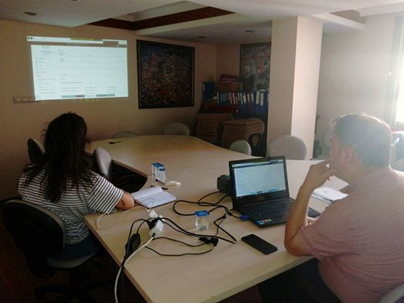](https://www.facebook.com/buldanticaretodasi/photos/a.374115932770523/1543215905860514/?type=3&eid=ARDPAvGNLN9-kKXMJG-ByLz5HX-qqW9eEg3gwGvIH2SynGeOllGRYdv3_mWBVopWJ1MOGc19VAh92qei&__xts__%5B0%5D=68.ARCkYQBTubE6GOKnsVX7hO0ACVjqkB8HdgYcuTjQnClgpyRoZhmCPjbETT0vJhH6jOygf2a3pRIHIXt58E-Ss_XtWxV_7WosAPS8ee0Z2IUqAL6K2mk9Ewoj1q_Zw54i87SSkJsQMiEKDg9aAWdNFP6a1rPIlWZLgeZ4NJWGLXFon68wu6hiZ5y80AhO8Pp2NVaUzesfnnZF0BkvE9YT9mxVmjmHrF2oRXc2dR0XFgGKDlbc25F6ztW2bbIaaqs9-enDxCc6PSMmHj60BqxUWZM7wLEK05aFYmnGB7O-36VqgUD7mzEgPziuYvjmc_Nhs2rmzsRjcmjXCsrsarmkKAoDVA&__tn__=EHH-R)](https://www.facebook.com/buldanticaretodasi/photos/a.374115932770523/1543215905860514/?type=3&eid=ARDPAvGNLN9-kKXMJG-ByLz5HX-qqW9eEg3gwGvIH2SynGeOllGRYdv3_mWBVopWJ1MOGc19VAh92qei&__xts__%5B0%5D=68.ARCkYQBTubE6GOKnsVX7hO0ACVjqkB8HdgYcuTjQnClgpyRoZhmCPjbETT0vJhH6jOygf2a3pRIHIXt58E-Ss_XtWxV_7WosAPS8ee0Z2IUqAL6K2mk9Ewoj1q_Zw54i87SSkJsQMiEKDg9aAWdNFP6a1rPIlWZLgeZ4NJWGLXFon68wu6hiZ5y80AhO8Pp2NVaUzesfnnZF0BkvE9YT9mxVmjmHrF2oRXc2dR0XFgGKDlbc25F6ztW2bbIaaqs9-enDxCc6PSMmHj60BqxUWZM7wLEK05aFYmnGB7O-36VqgUD7mzEgPziuYvjmc_Nhs2rmzsRjcmjXCsrsarmkKAoDVA&__tn__=EHH-R)

İş Makinası yenilenen sistem Eğitimine odamız adına Genel Sekreter Ayhan Emirdag katılmıştır.

[[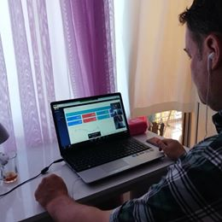](https://www.facebook.com/buldanticaretodasi/photos/pcb.1538911769624261/1538911682957603/?type=3&__tn__=HH-R&eid=ARDZUBdaP908Huhp9gmfgTf0xm2LLJmU_5MzUtLGJNmDoaB0k4yg48yod967AL55Ktgpr_o0fLSEhNag&__xts__%5B0%5D=68.ARAywXPcxirkxeChk4qL4mre2V1sfsTyrTSPNyLzPCodkgNUY2iP5doTEF9a6vVPvgUfAMLVKiVa9Ejc0Ux275KQsKWkga6M7KI6RDZnZOtAhsoNjr3gIDwxg7xvsWuoW7jZrdo_K5mmCB-21p0WWkGlX-vthn-IqRim8K0TT0MMhGooDxhs7kqg6uCO5sjoZDMSQp2Dj25ouVpDMlMMw6zUKGOaHT6qBw4J02JQKHuUc54ETkGcrUoyS0JoIblJe4y8YelukY24UuUCp7m8FP8WBqEVxCLcO5ijmaiNmzHoKWiVzXJg-6a9vf0wI2D-Mam1xxjjM0NLK7BRLTZQJPkM1Q)](https://www.facebook.com/buldanticaretodasi/photos/pcb.1538911769624261/1538911682957603/?type=3&__tn__=HH-R&eid=ARDZUBdaP908Huhp9gmfgTf0xm2LLJmU_5MzUtLGJNmDoaB0k4yg48yod967AL55Ktgpr_o0fLSEhNag&__xts__%5B0%5D=68.ARAywXPcxirkxeChk4qL4mre2V1sfsTyrTSPNyLzPCodkgNUY2iP5doTEF9a6vVPvgUfAMLVKiVa9Ejc0Ux275KQsKWkga6M7KI6RDZnZOtAhsoNjr3gIDwxg7xvsWuoW7jZrdo_K5mmCB-21p0WWkGlX-vthn-IqRim8K0TT0MMhGooDxhs7kqg6uCO5sjoZDMSQp2Dj25ouVpDMlMMw6zUKGOaHT6qBw4J02JQKHuUc54ETkGcrUoyS0JoIblJe4y8YelukY24UuUCp7m8FP8WBqEVxCLcO5ijmaiNmzHoKWiVzXJg-6a9vf0wI2D-Mam1xxjjM0NLK7BRLTZQJPkM1Q)